C V of DR. RAJASHREE MOHANTY

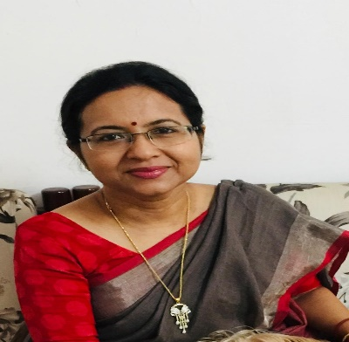

NAME: DR. RAJASHREE MOHANTY
DESIGNATION : READER IN ECONOMICS
Contact No.: 9437283531
Email: mohanty.rajashree1@gmail.com

EDUCATION :

Qualifications: M. A, M.Phil.,Ph.D
Title of PhD Thesis: Economics of Displacement NTPC ,Kanika- A Case Study.

PUBLICATIONS PROFILE :
- IMPACT OF DISPLACEMENT-ODISHA REVIEW PG-67, VOL- XVII NO.-2 & 4 ,2011
- BIKASH AND BISTAPAN-YOJANA ,PG-32 ,,2011
- DISPLACEMENT & GOVERNANCE –PUBLIC ADMINSTRATION , PG-101, VOL-XII
SEMINARS ATTENDED:

- State Level Seminar on Special Economic Zone – Industrial Progress & Human Displacement .
at Jajpur on 25-26 ,Sep- 2011.
- 92th Indian Economic Association at KIIT University on 27-29 Dec 2009.
- National Seminar at Vidyasagar University on 19 Mar 2013.
- International Seminar on Gandhiji”s Ideals and Practices – An Instrument of Social Change.
at Ekamra College on 27-nov 2019.
- National Seminar on Violence Against Women in Contemporary Society at Ekamra College on 25 jan 2020.
- Gender Budgeting at Gopabandhu Academy on 24-26 Nov 2016.
REFRESHER COURSES:

- 2003 UGC Refresher course at IIITMTM on 14-28 July 2003
- 2005 UGC Refresher course at Utkal University on 01-01-2005 to 21-02-2005.
- 2016 UGC Refresher course at Utkal University on27-06-2016 to 17-07-2016.

